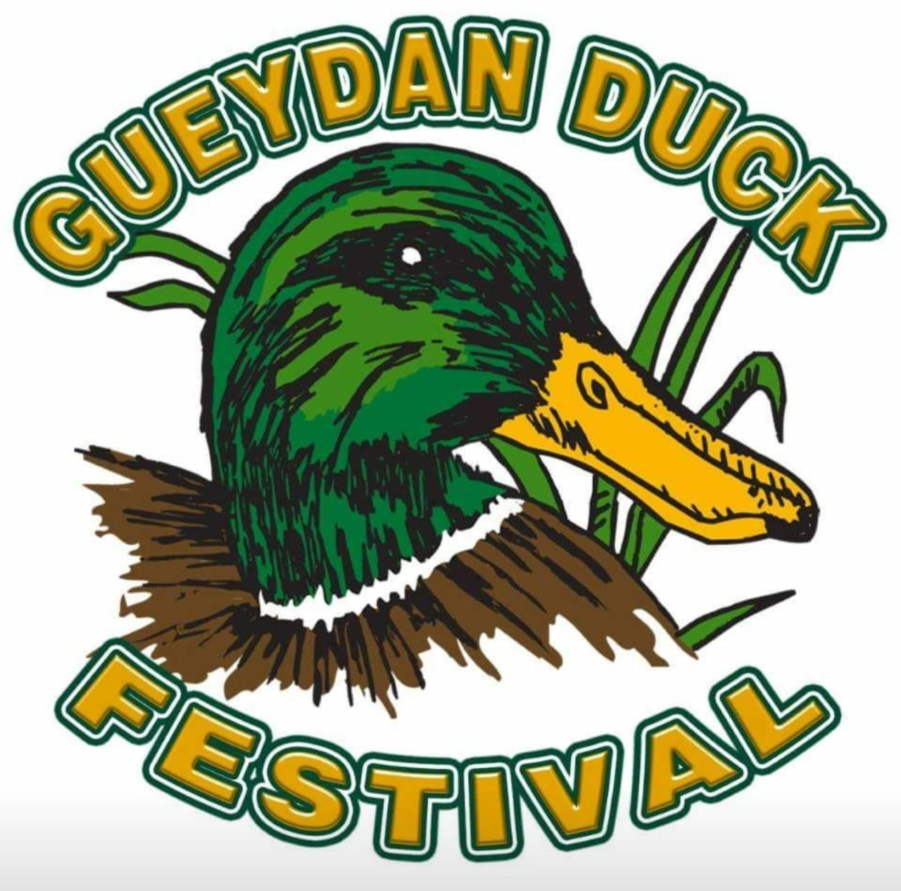
GUEYDAN DUCK FESTIVAL REGISTRATION FORM
DUCK AND GOOSE COOKING CONTEST ENTRY FORM
CHAIRPERSON: Ross Kibodeaux
PHONE: (337) 523-4830
RECIPE SUBMISSION REQUIRED UPON REQUEST
TEAM NAME:_________________________________________________________
CONTACT PERSON:_____________________________________________________
ADDRESS:____________________________________________________________
CITY:_______________________________________STATE:__________ZIP:_______
EMAIL ADDRESS:_______________________________________________________
RULES:
1. REGISTRATION FEE - $50.00
2. BEGIN COOKING AT 8:00 AM OR LATER.
3. JUDGING HELD AT 12:00 PM
5. COOKING TEAMS MUST PROVIDE ALL EQUIPMENT. ALL COOKING WILL BE UNDER PAVILION
4. ALL RECIPES ARE ACCEPTED. COOK-OFF IS A DUCK OR GOOSE ONLY CONTEST. SAMPLES MAY BE GIVEN AWAY TO THE PUBLIC AFTER JUDGING. THE COOK-OFF COMMITTEE WILL PROVIDE SAMPLE CONTAINERS.
5. Your dish will be judged on appearance, seasoning, and overall taste.

